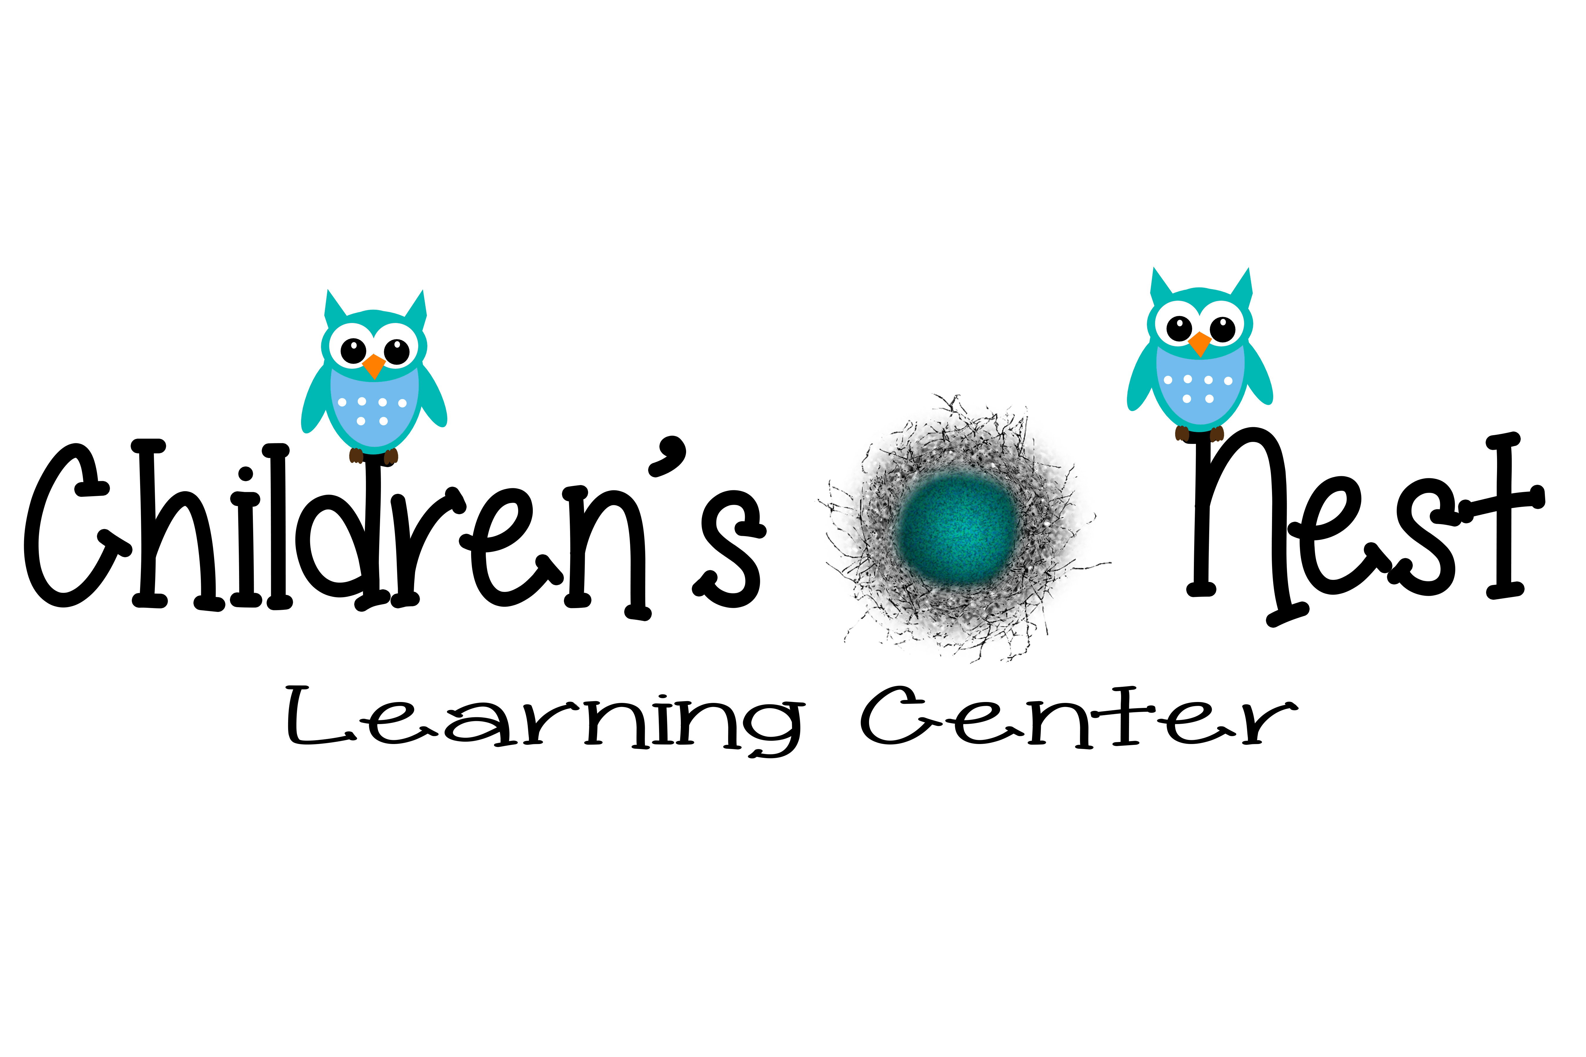
Parent
Handbook
J;lkjkljk;ljkj;
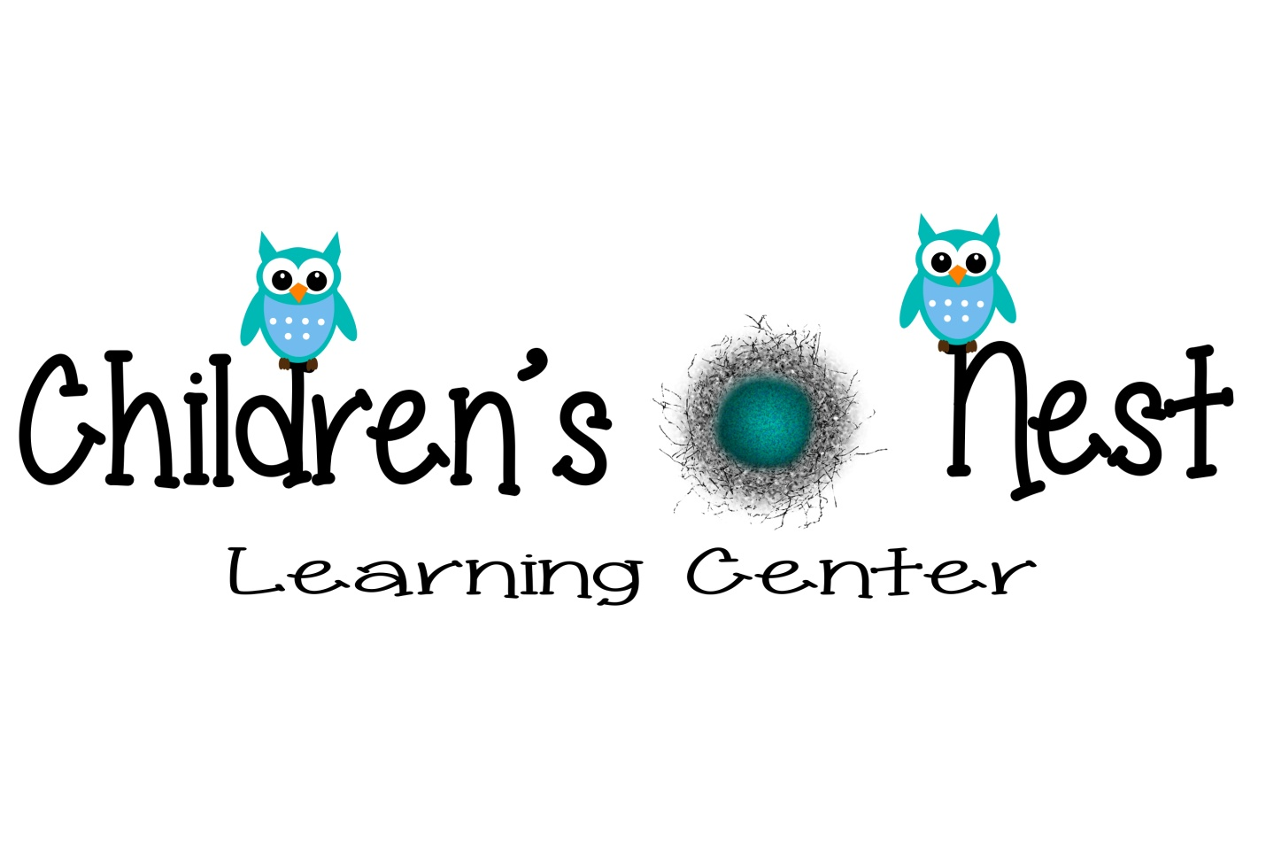Welcome to
Children’s Nest Learning Center
161 Laymantown Rd.
Troutville, VA 24175
Phone: (540)977-KIDS/ (540) 977-5437
Childrensnestlc@gmail.com
www. childrensnestlc.com
Hours of Operation: Monday - Friday 6:30 am- 6:00 pm
Children’s Nest Learning Center serves families with children from birth through 12 years of age. Care is provided to insure a safe environment for children from 6:30 a.m. to 6:00p.m. Qualified personnel will supervise the day to day operation of the Center under the direction (leadership) of the Owner(s) / Director. Workers will share their talents and gifts for children’s growth and enrichment.
This program will be implemented in a Christian and loving atmosphere to enhance children’s self-esteem and wellbeing.
Adopted August 2014
Mission Statement

At Children’s Nest Learning Center our mission is to provide quality child care that meets the needs of each child and their family in a safe, educational environment. Our focus is to provide a stimulating atmosphere and educational experience which in turn promotes each child's social, emotional, physical and cognitive development.
Our goal is to support and encourage the development of skills needed for our children to become life-long learners.

Our goals at Children’s Nest Learning Center are:
- To provide affordable, convenient, and reliable child care services
- To provide a nurturing environment
- To provide a curriculum based learning experience for our children
- To provide activities in a healthy, positive, and relaxed environment
- To provide and maintain continuity and consistency throughout their journey

Religious Practices

We feel that religious teachings are up to the parent; however the center will carry a Christian atmosphere. We will say a prayer before each meal (usually a song type prayer) and a bible story may be occasionally told during our story time. Sometimes God just comes up in conversation. For example, children often start to notice the different between boys and girls. The answer “because God made us different” usually seems to satisfy most preschoolers. If you object to bible stories or prayer please let us know.

We also usually have parties to observe holidays such as Christmas, Easter, Thanksgiving and Halloween. If you do not wish to have your child participate in these, please let us know.

Cultural Diversity

Each child comes to the center with a different set of experiences, knowledge and interest and Children’s Nest Learning Center seeks to build on the child’s home experiences, and acknowledge the range of cultural backgrounds of families. We have a genuine regard for all children and their language, culture and achievements. Their family is valued and their culturally diverse backgrounds are accepted and reflected in our programs.

Our Classrooms

Birth – 10 or 12 months Classroom
“The Nest”
In the Nest, Children’s Nest Learning Center realizes the importance of the growth and development of a child's first year. Our qualified staff offers an environment of Christian love and care as we partner with parents. The Nest provides a safe, nurturing atmosphere for up to 12 infants.

10 months to 16 months Classroom

The One-Year Old Room, offers Christian care and opportunities for children to explore, play, and interact through hands-on activities and music in their learning environment. The One-Year Old Room provides a safe, nurturing atmosphere for up to 8 toddlers.

16 months – 24 months Classroom

The 16 to 24 months, encourages guided experiences to promote independence and personal growth in your child through Christian care and love. The staff will be mindful of the beginning habits of toilet training. The 20 to 30 months room provides a safe, nurturing atmosphere for up to 10 children.

2 Year-Old Room

The 2 year old classroom helps develop early learning skills. These children will be introduced to working and playing in a group setting. The staff will continue to provide support to help children achieve independence in toilet training. The 2 year classroom provides a safe, nurturing atmosphere for up to 12 children.

Pre-Kindergarten Rooms (Early Beginners and PreK)

Our PreK promotes an exciting environment conducive to active learning. Through a strong curriculum based program, the children will have an opportunity to explore through a variety of hands-on activities such as music, art, group play, and other guided activities. Our PreK provides a safe, nurturing atmosphere for up to 20 children, two classrooms of 10 each.

After School Program

This care will be offered for students attending Colonial Elementary School. Transportation to the center will be provided through the Botetourt County Public Schools bus system. The hours are from the time school dismisses until 6:00 p.m. An afternoon snack will be provided. These children will participate in a variety of activities including homework time, music, art, organized games, and indoor/outdoor free play.

Summer Camp

Child care is provided for children entering kindergarten through age twelve.
An activities fee will be charged at the beginning of the summer. This fee will cover the cost of the field trips and other special activities. The children will go on a series of field trips including, but not limited to swimming, skating, bowling and miniature golf.

Accident and Health

An Accident Report form will be completed if your child is injured. If the injury warrants further medical attention, the appropriate action will be taken. We ask that you sign a medical release authorization form that will be kept on file in the office so it will be available in the event of a medical emergency.

We ask that you do not bring sick children to Children’s Nest Learning Center. If your child becomes sick at the Center, you will be notified immediately. You will need to make arrangements to pick up your child if they show any of the following symptoms: recurring fever of 101° or over, diarrhea, nausea and/or vomiting, or any other signs of communicable diseases. Your child needs to be symptom free for at least 24 hours prior to returning to the Center. Please notify the Center if your child is unable to attend school because of an illness and when they contract a contagious disease/illness.


Only prescription medications with the original label and a signed doctor's order will be given Children’s Nest Learning Center. A Medication Authorization Form must be on file in order for our staff to administer any prescription medication.

Within five (5) days of entrance to the Center, each child will be examined for head lice infestation. Upon receiving notification of a case of head lice, an additional employee will check the child to verify the findings. If head lice are found, parents will be notified and should make arrangements to pick up the child immediately. Notification will be sent to all other parents in the Center. Upon the child's return to the Center, he/she will be checked for lice again.

Attendance and Pick-Up

Parents MUST sign in and out daily at the Center. Please inform your child's teacher if your child is to be picked up early, will be out for the day, or will be taking a vacation week.

All adults picking up children will be required to punch in a security code at the main entrance before they will be able to enter the door. Your child will only be released to individuals that have your permission to pick up the child as stated on the child's registration form. Please provide your teacher with a note if your child will need to be released to someone who is not listed on the form (an out-of-town relative for example). The teacher or director will check the driver's license of any new individual to whom your child is released. The custodial parent has the right to be admitted to the Center as required by § 63.2-1813 of the Code of Virginia.

If a child arrives late to the Center and their class is away from the building, they will be placed in the classroom of the age group closest to their age or in the care of the Director or her designee.

In case of an emergency creating the center to discontinue care for the day resulting in immediate pick up the Director of Children’s Nest Learning Center will contact each parent(s) via phone call or text message as soon as possible informing the parent of the situation at hand. (For example: inclement weather, fire, power outages, etc.)

Emergency Contact Numbers: (during or after hours)

Renee Slusser – (540) 598-7575
Rhonda Spangler - (540) 580 - 5552

Conferences

Please feel free to ask your child's teacher for a conference if you would like to discuss his or her learning or behavioral progress. All information discussed and shared will be documented and kept confidential.

Children’s Nest Learning Center will provide scheduled conferences at least twice a year. Dates will be determined and notices will be sent home in an appropriate time frame. Conferences times will be based on the availability of the Lead Teacher, Director and Parent(s).

The Children’s Nest Learning Center Director are always open to comments and/or suggestions that will help improve our Center.

Daily Schedules

Each classroom teacher will provide you with a general schedule of daily events such as gross motor play, outside play, meals and snacks, learning times, naptimes, diapering and bathroom schedules (infants & toddlers), etc.

Daily Classroom Schedule
Age: 10 to 16 Months
6:30am-8:00am | Arrival of children, greetings, supervised free play. (Such as table toys, board games, books, puzzles, etc.)
8:00am-8:30am | Clean Up/Wash Up/Diapers ( as needed )
8:30am-9:00am | Morning Snack Time
9:00am-9:30am | Center Free Play (puzzles, blocks, cars, baby dolls, etc.)
9:30am-10:30am | Quiet Time/ Rest Time / Diapers
10:30am-11:00am | Outdoor Play / Multipurpose Room creative movement / Craft Time or Table toys
11:00am–11:30am | Wash Up/ Diapers/ Music Time
11:30am-12:15pm | Lunch Time
12:15-12:45pm | Clean Up from Lunch, Diapers ( if needed)
12:45pm-2:45pm | Nap/Rest Time
2:45pm-3:15pm | Wake up/ Diapers/ Wash Up
3:15 pm-3:30pm | Afternoon Snack Time
3:30pm-4:00pm | Outside Play ( Weather Permitting) / Center Free Play
4:00 pm-4:45pm | Center Free Play/ Table Toys (art, music, indoor games, etc.)
4:45pm-5:00pm | Diapers
5:00pm-6:00pm | Free Play/ Clean Up / Prepare for Departure

Daily Classroom Schedule
Age: 16 to 24 Months
6:30am-8:00am | Arrival of children, greetings, supervised free play. (Such as table toys, board games, books, puzzles, etc.)
8:00am-8:30am | Clean Up/Wash Up/Diapers/ Potty Time
8:30am-9:00am | Morning Snack Time
9:00am-9:30am | Circle Time/ Planned Structured Activities/ Active Story Time / Craft Time (following directions, number and color recognition, alphabet, songs, etc.)
9:30am-10:00am | Center Free Play (blocks, puzzles, baby dolls, cars, little people sets, etc.)
10:00am-11:00am | Outdoor Play ( Weather Permitting ) / creative movement
11:00am–11:30am | Wash Up/ Diapers/Potty Time/ Music Time
11:45am-12:30pm | Lunch Time
12:30-12:45pm | Clean Up from Lunch, Diapers/ Potty Time ( if needed)
12:45pm-2:45pm | Nap/Rest Time
2:45pm-3:00pm | Wake Up/Diapers/ Potty Time/ Wash Up
3:00pm-3:30pm | Afternoon Snack Time
3:30pm-4:00pm | Outside Play ( Weather Permitting) / creative movement
3:45pm-4:45pm | Center Free Play
4:45pm-5:00pm | Diapers/ Potty Time
5:00pm-6:00pm | Free Play/ Clean Up / Prepare for Departure

Daily Classroom Schedule
Age: Two Year Olds
6:30am-8:00am | Arrival of children, greetings, supervised free play. (Such as table toys, board games, books, puzzles, etc.)
8:00am-8:30am | Clean Up/Wash Up/ Restroom
8:30am-9:00am | Morning Snack Time
9:00am-11:00am | Circle Time/ Curriculum Learning Time  (following directions, number and color recognition, alphabet, weather, calendar, songs, etc.)
11:00am–11:30am | Outside Time/ Creative Movement
11:30am-12:00pm | Clean Up/ Potty Time / Wash Up
12:00 pm -12:30pm | Lunch Time
12:30-12:45pm | Clean Up from Lunch, Potty/Diapers ( if needed)
12:45pm-2:45pm | Nap/Rest Time
2:45pm-3:00pm | Wake Up/ Potty / Wash Up
3:00 pm-3:30pm | Afternoon Snack Time
3:30pm-4:00pm | Outside Play ( Weather Permitting) / creative movement
4:00pm-4:45pm | Center Free Play (puzzles, blocks, books, cars, baby dolls, etc.)
4:45pm-5:00pm | Potty Time
5:00pm-6:00pm | Free Play/ Clean Up / Prepare for Departure

Daily Classroom Schedule
Age: Pre- Kindergarten (Early Beginners and PreK)

6:30am-8:00am | Arrival of children, greetings, supervised free play. (Such as table toys, board games, books, puzzles, etc.)
8:00am-8:30am | Clean Up/ Potty / Wash Up
8:30am-9:00am | Morning Snack Time
9:00am-11:00am | Circle Time/ Curriculum Learning Time  (following directions, number and color recognition, alphabet, weather, calendar, songs, etc.)
11:00am–11:30am | Outside Time/ Creative Movement
11:30am-12:00pm | Clean Up/ Wash Up/ Potty Time
12:00 pm -12:30pm | Lunch Time
12:30-12:45pm | Clean Up from Lunch, Potty ( if needed)
12:45pm-2:45pm | Nap/Rest Time
2:45pm-3:00pm | Wake Up/ Potty / Wash Up
3:00 pm-3:30pm | Afternoon Snack Time
3:30pm-4:00pm | Outside Play ( Weather Permitting) / creative movement
4:00pm-4:45pm | Center Free Play (puzzles, blocks, books, cars, baby dolls, etc.)
4:45pm-5:00pm | Potty Time
5:00pm-6:00pm | Free Play/ Clean Up / Prepare for Departure

Discipline

Children’s Nest Learning Center staff will handle discipline situations in a loving, positive, and consistent manner. The behavior problem will be discussed with the child and he/she will be asked to correct the inappropriate behavior. If the problem involves hurting another child or if the child is hurting himself/herself in a dangerous way, the child will be placed in ''time out". During "time out" the child will be placed in a designated area away from other children for a brief time period (minutes per age).

The following are inappropriate forms of discipline that will not be tolerated at Children’s Nest Learning Center: shaking a child for any reason, rough, physical handling of a child such as jerking or dragging a child by the arm, forcing a child to eat or withholding food (including dessert) from a child as punishment, forcing a nap or withholding sleep from a child, punishing a child for a toileting accident, or verbally abusing a child, including but not limited to threats or belittling remarks about the child or the child’s family. Physical punishment of any sorts will not be tolerated as well as any founded child abuse accusations or use of corporal punishment by a Children’s Nest Learning Center employee will warrant immediate termination.

Dismissal from Center

Children’s Nest Learning Center reserves the right to dismiss any child that is unable to adjust appropriately to the Center. In the event there is a problem with a child and an incident occurs, you will be notified in writing through an Incident Report. The Director will be available to meet for a conference if needed. If a child is sent to the Director three times, he or she will be placed on probation. The Director will specify the length of the probationary period. The child will be dismissed from the Center if the problem persists after the probationary period. The following list outlines reasons for termination of a child from the program:

- Possession of a dangerous weapon -immediate dismissal.
- Possession of drugs, alcohol-immediate dismissal.
- Aggressive Behaviors including repeated biting.
- Constant disrespect for teachers and/or other students and failure to follow rules.
- Failure of parent to pay fees when scheduled. (See Financial Policies)
- Failure of parent to pick up child on time. (See Financial Policies)

Dress Code

We encourage you to dress your child in an appropriate manner that will make them comfortable and safe. It will be required that children wear appropriate closed toed shoes to ensure safety during outdoor and indoor playtime. When dressing your child please remember that we are a model a Christian atmosphere and we do not allow clothing that characterizes violence, inappropriate language, or does not portray good role models.

Emergency Drills

Children’s Nest Learning Center holds emergency drills once a month in the event of a fire, natural disaster, or wartime event. The signal for an emergency drill is a loud alarm indicated by our fire alarm system. The signal can also be directed over the intercom system. Children will form a single-file line led by teacher and leave the building quickly and quietly as designated evacuation procedure posted in each of the classroom.

Parents will be contacted in the event of an emergency situation by administration of Children’s Nest Learning Center via phone call or text message. Students will be evacuated to the open field to the right of the building (when looking at the building) if it is too dangerous to remain near the main building. If a threat takes place outside the building that would endanger the children if they were to exit, parents shall gather at the Food Lion parking lot where they will be kept informed about the situation and cleared to enter the building when the area is secured.

Enrollment Requirements

Children’s Nest Learning Center enrolls students regardless of race, color, gender, national and ethnic origin, or religion provided that the following requirements are met:

Age- Children’s Nest Learning Center is open to children between the ages of birth through 12 years of age.

Birth Certificate/Verification of Birth- The law of Virginia requires verification of birth. A copy of the birth certificate must be included with the registration form.

Parent Handbook Agreement- This form is located at the back of the parent handbook. Your signature represents your support of the Children’s Nest Learning Center as well as the philosophy and policies set forth in this handbook.

Physical and Immunization record- The law of Virginia requires documentation of a child's physical examination within 30 calendar days of enrollment. A current immunization record must also be provided prior to enrollment. Your physician has the required forms at his/her office. An updated immunization record must be given when the child receives a new vaccination. State law requires that the Center be given an· updated immunization record every six months for children under two years of age and once every year for children two years of age and older.

Registration- A Registration Form must be completed and on file for each child. Upon ·enrollment in the Children’s Nest Learning Center, a $50.00 registration fee is required and is NON REFUNDABLE.

Field Trips

Your child's teacher will notify you in advance of any field trip plans. From time to time we may ask for volunteers to assist the staff by helping plan trips or by helping chaperone. In order for your child to attend, we MUST have a signed permission form. Some of our field trips will require a small fee. These fees are extra and are not included in the one-time registration fee or weekly tuition. Transportation for field trips will be provided by the Children’s Nest Learning Center bus, vans, or SUVs.

Financial Policies
When you register your child, you are entering into a financial agreement with Children’s Nest Learning Center for 5 days per week, Monday- Friday. In the event your child is absent for any reason (sickness, weather, holidays, appointments, etc.) you will not receive a reduction in tuition.

In the event that the Botetourt County Public Schools are closed (such as conference days, snow days, teacher workdays, etc.) tuition rates for the After School Program will be $15.00 additional to their weekly rate.

Each pre-school child will receive 2 weeks of vacation time per our physical school year (August 1 through July 31). For new enrollments you must wait for 3 months before vacation time is allowed to be used if you begin during middle of school year your time will be prorated for the year. Vacation time is only allowed to be used in weekly increments. You are not able to transfer these benefits to other siblings or children in the Center. You must give two weeks’ notice to the Director before taking your vacation time to receive the vacation rate. This prior notice helps us when planning activities and scheduling staff work hours.

Due to limited space and staffing, we are not able to hold your child's spot for long periods of time (such as through a summer break). You will have to re-enroll your child when you decide to return. Note : Vacation Time WILL NOT be granted to those families that wish to pull out or drop to part time for the summer.

All tuition must be paid by Monday of each week. At this time Checks and Cash can be used to pay tuition and fees. Please use the cash box located outside of the office door, Place all cash in envelope with child’s first and last name. If payment is not received by Tuesday, starting Wednesday a late fee of $5.00 per day will be added to your weekly tuition. If no payment is made for two consecutive weeks it will result in the inability of your child to attend until payment is received and permission from Director has been given for child to return to Children’s Nest Learning Center.

In the event that your check is returned to Children’s Nest Learning Center, a returned check fee of $35.00 will be charged. The returned check must be replaced with a money order or cash. After three (3) returned checks, you will be required to pay all fees in cash or money order.

If your child is not picked up by 6:00 p.m., a late fee of $1.00 per minute will be charged. Repeated failure to pick up your child by 6:00 p.m. may result in the dismissal of your child from Children’s Nest Learning Center. If your child is not picked up by one (1) hour after closing and no contact has been made with parent or emergency contacts listed, the Center will contact the Department of Social Services.

Children’s Nest Learning Center requires a two-week notice in writing prior to withdrawing your child.

A $50.00 annual supply fee per enrolled child will be due during the month of August/September. If your child is enrolled after August of the physical year, activity fee will be charged at time of registration.

Hours of Operation

Children’s Nest Learning Center will open at 6:30 a.m. and closes promptly at 6:00 p.m., Monday through Friday with the following holiday exceptions:



New Year's Day -Closed Memorial Day -Closed
4th of July -Closed
Labor Day -Closed
Thanksgiving Day -Closed
The day after Thanksgiving –Closed
Christmas Eve -Closed
Christmas Day -Closed

Items Kept at the Center

Please remember to write your child's name on all personal items brought into the classroom. Please check with your child's teacher for a list of items they will need since each classroom is different. Examples of some of these items would include extra clothes, diaper, and wipes. All personal meals and snacks are to be individually labeled per item with name and date and left in kitchen.

Sunscreen, diaper ointment, and insect repellant are optional items that can be left at the Center, but it is required that written authorization be given in order for these items to be applied. All items must be in their original container with the child's name clearly marked. A record will be kept regarding the frequency of application for diaper ointment and insect repellant. All sunscreens must be hypo-allergenic and a minimum SPF 15.

Play knives, play guns, weapons, and toys that depict non-Christian like characters are not permitted at the Center.



Meals

Children’s Nest Learning Center will provide 2 snacks (mid-morning, afternoon) and a hot lunch. These are included in the cost of tuition. Parents are encouraged to feed their child a nutritious breakfast before dropping them off. However, children may bring certain breakfast items before 8:00 a.m. Only a cup of milk will be provided, please do not bring cups/sippy cups or bowls from home. Acceptable breakfast items would include Pop-Tarts, bagels, cereal bars, muffins, and fruit.

Each month you will be provided with a lunch menu. You may pack your child's lunch but a reduction in tuition will not be given.

Organizations

The Children’s Nest Learning Center Owner(s)/ Director will oversee the Learning Center. The Program Director/ Owner(s) will supervise the teachers, aides, and other staff hired to implement the center.

Reporting Child Abuse

If child abuse or neglect is suspected, a classroom teacher will discuss his/her concern with the Director. All suspected cases of child abuse and neglect must be reported by the Director or Teacher suspecting the abuse to the Department of Social Services Child Protective Services Division (DSS). This can be done by calling the state hotline at 1-800-552-7096 or by calling the local Child Protective Services office. If a teacher suspects child abuse, she/he is legally required to report it to DSS. Even if some members of the Center disagree, whoever observes the suspicious circumstances is legally responsible. Any employee found guilty of failure to do so will be subject to a fine. Employees are immune from any civil or criminal liability in connection with any report as long as there was no malicious intent.

Special Events
If you wish to have a birthday celebration for your child in his/her class, you will need to make advance arrangements with the classroom teacher or Director. If you are providing snacks such as cupcakes, cookies, ice cream, etc., they will be served as dessert at lunch or along with afternoon snack.
Weather

Children’s Nest Learning Center will remain open unless extreme weather conditions occur that make it impossible for our staff to get to the Center safely.

The Children’s Nest Learning Center Director will have an announcement made on television stations WDBJ-7 and WSLS-10.

When weather conditions become extreme during the day and Botetourt County Public Schools dismiss early, the after school care program will be open and your child will be bused to the Center. ·

·



Parent Handbook
Contract Agreement

I have read the Children’s Nest Learning Center Parent Handbook and agree to support the philosophy and policies of the
Children’s Nest Learning Center.

Name (Print)
Name (Signature)
Date

Please sign and return to Children’s Nest
Learning Center Office

